Project Design Phase

Problem – Solution Fit
Date | 14 July 2026
Team ID | ----------------
Project Name | Shopezz – MERN E-Commerce Platform
Maximum Marks | 2 Marks

Problem – Solution Fit Overview
Shopezz is a full-stack MERN e-commerce platform developed to simplify online shopping through a secure, responsive, and user-friendly web application. The project addresses common challenges faced by online shoppers such as complicated navigation, fake products, delayed deliveries, insecure payment methods, and poor customer support. By integrating React.js, Node.js, Express.js, and MongoDB, Shopezz delivers a modern shopping experience with efficient product management, secure authentication, shopping cart functionality, wishlist management, order tracking, and an admin dashboard.
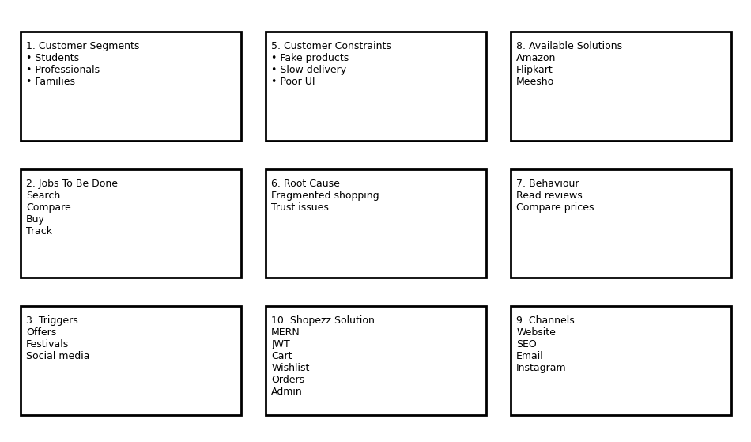

Detailed Problem Analysis
- Customers spend significant time comparing products across multiple websites.
- Many online stores provide insufficient product information and unreliable reviews.
- Users abandon purchases because of lengthy checkout processes.
- Delayed deliveries and lack of order tracking reduce customer trust.
- Limited payment methods discourage potential buyers.
- Small businesses struggle to manage products, inventory, and customer orders efficiently.

Proposed Shopezz Solution
Shopezz overcomes these challenges through a scalable MERN architecture. The platform offers a responsive user interface, secure JWT authentication, role-based admin access, advanced product search and filtering, shopping cart, wishlist, online order management, and real-time order status updates. The administrator can manage products, categories, users, and orders from a centralized dashboard.

Key Features
- Responsive React.js frontend for desktop and mobile devices.
- Secure login using JWT and encrypted passwords with bcrypt.
- MongoDB Atlas for scalable cloud-based data storage.
- Product categorization, search, sorting, and filtering.
- Shopping cart and wishlist management.
- Order placement, order history, and delivery tracking.
- Admin dashboard for inventory and order management.
- Future enhancements include AI-based recommendations and multiple payment gateways.

Expected Benefits
Customers receive a fast, secure, and reliable shopping experience while administrators gain efficient control over inventory, products, and customer orders. The scalable MERN architecture ensures easy maintenance, high performance, and future extensibility.

